SLNC COVID-19 Safety Plan
Introduction
All Cross Country BC Member Organizations are required to develop COVID-19 Reopening Safety Plans that explicitly present the measures that will implement and maintain over the coming 12 to 18 months. Plans must be in compliance with orders and guidance from the Provincial Health Officer and must be made available to the public either by posting on the wall of the organization’s facility or on its website.
SLNC has created this document, based on Cross Country BC’s guidance document. This document has been cross referenced and is aligned with the viaSport Return to Sport Guidelines for B.C. document , the WorkSafeBC COVID-19 Safety Plan Checklist and the Nordiq Canada Risk Assessment and Mitigation Checklist Tool.
The Provincial Health Officer’s direction is that COVID-19 Reopening Safety Plans should cover 3 things: (1) Processes to open safely, (2) Measures to keep people safe to avoid further outbreaks, and (3) A plan in the event that a case or outbreak should occur. The 5 principles from B.C.’s Restart Plan should be used to create COVID-19 Reopening Safety Plans:
To reduce the risk of the virus spreading through droplets in the air, SLNC is implementing protocols to protect against identified risks.

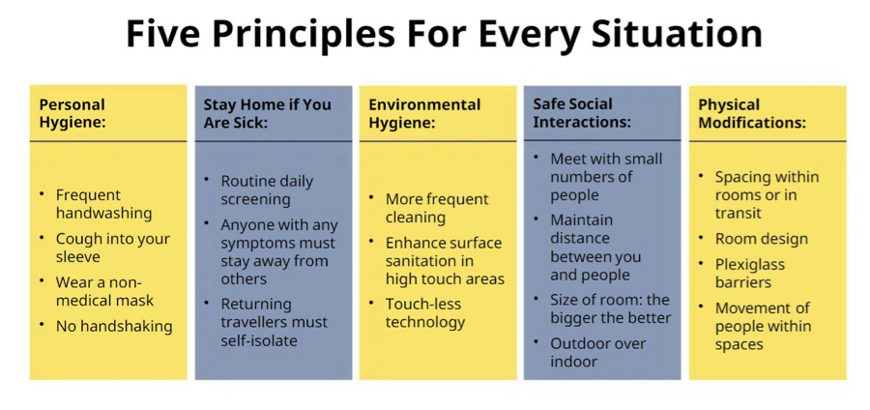

Club Knowledge and Awareness About COVID-19 risks and public health info
SLNC Manager Troy Hudson and Program Director Eric de Nys are responsible for having a deeper understanding of the risks of COVID-19, including transmission routes and best practices for limiting spread. Troy’s contact information is troy@sovereignlake.com SLNC has placed the following links on our website here and these will be reviewed daily to ensure we have current information- Interior Health ,BC Centre for Disease Control, Government of Canada-Health Services, Dr. Bonnie Henry & Minister Adrian Dix COVID-19 Updates r
Information regarding vulnerable populations will be included on the website and via direct email to all participants prior to their first session.
COVID-19 information will be shared with participants and staff as follows:
  - via links on the SLNC website here (need to hyperlink)
  - via direct email to participants
  - via coach prior to each session
Club Policies Regarding COVID-19
The following COVID-19 policies have been created-
Cross Country Protocols:
- 2020 SLNC Participant Agreement -COVID-19
- All participants must sign a Participant Agreement that contains Acknowledgement of Risk prior to their first session.
- SLNC COVID-19 Safety Reopening Plan
Note SLNC members must have signed the current Nordiq Canada waiver.
Access and Programming
- Everyone must sanitize hands when arriving, and prior to departure.
- Cars will park widely spaced
- Upon arrival participants will be reminded of hygiene protocols, and to utilize the ‘Get in, train and get out’ principle.
- Coaches will verbally confirm that all participants remain healthy at the end of practice.
- Only staff will access the lodge/storage/sheds to distribute equipment for participants.
- Coaches will remind participants at the start of each session of the training flow pattern
- SLNC may limit numbers of participants in a group.
- Start times of practice sessions may be staggered to allow small groups to start sequentially

Operations
Prior to programs commencing, SLNC will communicate the 2020 COVID-19 Reopening Safety Plan to staff and participants via email and on the SLNC website.
Staff will have in person, onsite training about personal safety procedures and physical distancing requirements prior to programming commencing.
Participants will have updates and ongoing education at every practice.
Identified touch points at SLNC such as washrooms, doors, kitchen area will be cleaned by staff as per the daily cleaning schedule.
Signage posted at the club will include Physical Distancing, Hygiene and COVID-19 symptom list
Hygiene
The lodge will be cleaned and sanitized by staff twice a day. A daily record will be kept onsite of all cleaning. Staff and participants will be required to sanitize their hands both when entering and leaving the site along with wearing a mask. The downstairs washrooms will be open and accessible during lodge operational hours. The lodge will not have any indoor seating for the foreseeable future.

Equipment Cleaning and Sanitization
All rental equipment will be sanitized with appropriate products (ski, boots, poles require different products). Staff will be solely responsible for cleaning rental equipment.
Safety Equipment
Staff/Coaches have individually assigned equipment as follows-
- Group first aid kits
- Individual masks and gloves
- Group radios (where applicable)
Health Monitoring
Participants should note that in COVID-19 they may identify as being in a vulnerable population and at high risk. Information regarding vulnerable populations will be included on the SLNC website and via direct email to all participants prior to their first session. Those identified at risk will be informed of information on the websites such as BC Centre for Disease Control.
Vulnerable populations may include-
• older adults
• those with underlying medical conditions and/or compromised immune system
Self-screening must be undertaken daily prior to attending a training session. Here is a link to a Self Assessment Tool
If a participant or staff member is COVID symptomatic they should contact SLNC club manager Troy Hudson troy@sovereignlake.com or Program Director Eric de Nys eric@sovereignlake.com
At the start of each training session staff/coaches will verbally confirm that all participants have done such a check and are symptom-free. A daily record of this information will be kept and signed by the session coach.
Public Health Authority information about screening, possible self-isolation, and quarantine requirements is available here
SLNC will store participants attendance records for 30 days. These records include acknowledgement of self-screening and that participants are not COVID-19 symptomatic.
Non-Compliance
Non-compliance will be addressed by the following 3 steps:
1. The first instance, if minor will be addressed by the participant being required to attend an education session with the club manager or a coach prior to attending another practice. If the instance is a major infraction (deliberate refusal to comply) step 2 will apply immediately
2.The second instance of non-compliance (or first instance if a major infraction) will result in the participant being denied access to SLNC programs and facilities for 14 days following the incident. Also, during that time the participant will be required to attend an education session with the club manager or a coach prior to resuming training. In order to return the participant must agree in writing to comply with all procedures and policies, and acknowledge that if there is another instance of non- compliance that they will be unable to participate in any SLNC programs for the 2020-2021 season or access any SLNC facilities.
3.If the participant has another instance of non-compliance they will be immediately notified via email that they will be denied access to SLNC programs and facilities for the remainder of the 2020 season.
SLNC Medical Response Plan
Medical Lead-Troy Hudson
Medical lead will communicate with individual who self-reports COVID-19 symptoms, and with local health authorities.
Communications Lead-Candace Bourque
Communication Lead will facilitate all internal communications regarding a suspected or confirmed COVID-19 case.
If a there is a suspected or confirmed case of COVID-19 at the club Medical Lead will:
- Immediately report and discuss the suspected outbreak with the Medical Health Officer (or delegate) at the health authority.
- Cooperate with local health authorities if contacted by a medical health officer in the course of contact tracing.
- Immediately close the club and implement enhanced cleaning measure prior to re-opening.
  - Implement your illness policy and advise individuals to:
self-isolate
  - monitor their symptoms daily, report respiratory illness and not to return to activity for at least 10 days
- use the COVID-19 self-assessment tool at BC COVID-19 Self-Assessment Tool to help determine if further assessment or testing for COVID-19 is needed.
- Individuals can contact 8-1-1 if further health advice is required and 9-1-1 if it is an emergency.
If there is a suspected or confirmed case of COVID-19 at the club, Communications Lead will:
- Access the club data base where contact details for all participants and staff has been created, including emergency contacts. This list will enable prompt communication should any emergency require connecting with staff and participants
- Immediately communicate with all club participants and staff to advise of the situation
- Communicate the club closure and cleaning procedures that will be completed prior to the club re-opening
- Communicate the importance of daily self-screening for all participants and staff

- Ensure that all participants and staff are able to readily communicate with the Communication
Approvals and Publishing
SLNC’s COVID-19 Safety Plan is posted on our website and updated frequently.

